Reading Requirements: Vocabulary Expansion

Steps for Expanding Vocabulary:
- Define prefixes and suffixes.
- Hint: Use the commonly used prefix and suffix handout. It has the most common prefixes and suffixes, their definition, and an example.
- Look up and define the root: the word without any prefixes or suffixes
- Record this definition and the part of speech
- Infer the definition:
- Use the definitions of the root word, the prefixes, and the suffixes to create a working definition
- this is a cognitive (mental) step; it does not get recorded as a physical step.
(DO THIS IN YOUR HEAD, do not write this definition on your cards or document)
- Look up the actual definition:
- Hint: There are often multiple definitions for a single word. Use the definition that makes the most sense for the situation.
- DO NOT use a definition you do not understand. It does you no good. Make sure the definition you record is one that you understand, or put it in your own words before you record it
- Record the definition and part of speech
- Create an association
- Picture: illustrate your word by drawing or using pictures found online
- Sentence: use the word in a sentence or record the sentence from your text
- Rhyme or Riddle: create a way to remind you the meaning by using a rhyme or a riddle

Example of HOW your document should look

- Hecklers
Prefix: none
Suffix:-er, -s; one who, plural
Root: Heckle (verb); interrupt with aggressive comments or abuse.*
Hecklers(noun); people who try to embarrass you.

*Note: the original definition was “interrupt (a public speaker) with derisive or aggressive comments or abuse” but I chose to use a piece of it based on what would help me most.

- Velocipede
Prefix: veloci-; swift
Suffix:-pede; foot
Root: none
Velocipede (noun); an early form of bicycle*

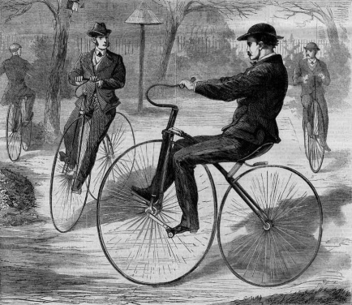

*Note: the original definition was “an early form of bicycle propelled by working pedals on cranks fitted to the front axle” but I chose to use the part that was most relevant for me.

Vocabulary Expansion: The Assignment

For each of the following words, follow the steps for expanding vocabulary to create a document or note cards. These words are the combined list of words that was created from independent reading. This is to be completed by Wednesday, November 13th.
After this list is completed and submitted, you will be required to add to your list weekly. This is a part of your reading requirements and must be submitted every Wednesday in order to receive full credit for reading in this class. To do this, you must continue to record new vocabulary as you read. A minimum of 5 words a week is required.

Hecklers | Melancholy | Velocipede | Rubbish | Instamatic
Pastureland | Rookie | Bust | Hazing | Awed
Apprehensive | Descriptive | Courteously | Wither | Thither
Ubiquitous | Exuberantly | Rendezvous | Nonchalantly | Unrequited
Cynical | Morbid | Phosphorescent | Wondrous | Calyx
Hewn | Dreamt | Fazed | Chemotherapy | Ecstasy
Exile | Exorcise | Prelude | Branded | Stupidity
Endures | Perpetuated | Vermin | Incantation | Inaudible
Sprawled | Strewn | Entreatingly | Emissary | Inquisitor

